ENTERPRISE DOCUMENT CLASSIFICATION
Implementation & Deployment Guide
End-to-End Implementation from Project Foundation to AKS Deployment and Power BI Reporting
Document Information | Value
Document type | Customer / Internal Implementation Guide
Version | 1.0
Scope | Enterprise document classification MLOps pipeline
Primary platform | Microsoft Azure
Deployment target | Azure Kubernetes Service (AKS)
Reporting | Microsoft Power BI
Model approach | TF-IDF + Logistic Regression
Classification service | Azure AI Document Intelligence – Custom Classification

Document Navigation
The guide is organized into phases so that a customer or implementation engineer can follow the deployment from the initial project setup through production-style deployment and reporting.
Right-click this field in Word and select "Update Field".

Implementation Phases
- Phase 1 — Project Foundation and Development Environment
- Phase 2 — Azure Storage and Document Ingestion
- Phase 3 — Azure AI Document Intelligence – Custom Classification
- Phase 4 — Azure Machine Learning – Dataset and Model Training
- Phase 5 — Model Registration and Inference API
- Phase 6 — Containerization and Azure Container Registry
- Phase 7 — Azure Kubernetes Service Deployment
- Phase 8 — GitHub Actions CI/CD and Azure Identity
- Phase 9 — Power BI Reporting and Dashboard

1. 1. Business Problem and Proposed Solution

1.1 Current Process Without AI
A company receives many documents that must be classified before they can be routed or processed.
Typical document types include:
- Invoice
- Resume
- Contract
- Purchase Order
Employees traditionally perform the following activities:
- Open the document
- Read the document
- Determine what type of document it is
- Move or route it to the appropriate department
This manual process introduces several problems:
- Slow processing
- Human classification errors
- Higher operational cost
- Difficulty scaling when document volumes increase

1.2 Proposed Solution
The implemented solution allows a customer to submit a document and automatically process and classify it.
The system performs the following activities:
- Reads the submitted document
- Uses Azure AI Document Intelligence to analyze the document
- Uses the machine-learning classifier to identify the document type
- Stores the classification result
- Exposes the classification API through the deployed application
- Makes classification results available for Power BI reporting
Implementation Note: The implementation separates document understanding from machine-learning classification. Document Intelligence is used for document analysis/OCR, while the trained TF-IDF + Logistic Regression model performs the final text classification.

2. Architecture
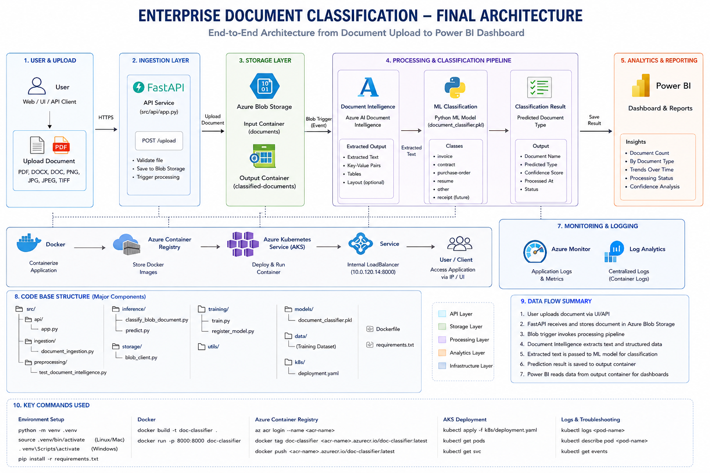

2.1 End-to-End Logical Flow
Document
↓
Azure Blob Storage
↓
Azure AI Document Intelligence
↓
Extracted Text
↓
TF-IDF + Logistic Regression Model
↓
Predicted Document Type
↓
FastAPI Application
↓
Docker Image → Azure Container Registry
↓
Azure Kubernetes Service
↓
Classification Result / JSON Output
↓
Power BI Dashboard
Implementation Clarification: The original implementation documentation referred to Azure AI Foundry in the high-level scope. The implemented document-processing component is Azure AI Document Intelligence / Document Intelligence Studio, which is the service described in the execution steps below.

1. Phase 1 — Project Foundation and Development Environment

1. Create GitHub Repository
Create the repository used to hold the application, ML, infrastructure, Kubernetes and CI/CD assets.
Setting | Configured Value
Repository name | enterprise-document-classification-pipeline
Visibility | Private
Description | Production-grade MLOps solution for automatic enterprise document classification using Azure AI Document Intelligence, Azure Machine Learning, GitHub Actions, AKS and Power BI.
Initial files | Do not add README, .gitignore or License during repository creation; create them in the project.

2. Create Local Project Folder
Create the project folder locally and use it as the VS Code workspace.
D:\Projects\
enterprise-document-classification-pipeline
D:\Projects\enterprise-document-classification-pipeline

3. Open the Project in VS Code
Open the project folder in Visual Studio Code.
code .

4. Verify Required Software
Open Command Prompt or a VS Code terminal and verify the required tools.
python --version
pip --version
git --version
az --version
docker --version
kubectl version --client
code .
Implementation Note: The implementation used Python 3.11.x. The exact versions used in a customer environment should be validated against the approved dependency and platform matrix.

5. Install VS Code Extensions
Install the following extensions:
- Python
- Pylance
- Azure Tools
- Docker
- GitHub Actions
- YAML
- Jupyter

6. Create the Python Virtual Environment
Create and activate the project-specific Python virtual environment.
python -m venv .venv
.venv\Scripts\activate
python -m pip install --upgrade pip
After activation, the terminal should display the virtual-environment indicator, for example:
(.venv)

7. Install Initial Python Packages
pip install azure-ai-documentintelligence
pip install azure-ai-ml
pip install azure-identity
pip install azure-storage-blob
pip install pandas
pip install scikit-learn
pip install mlflow
pip install fastapi
pip install uvicorn

8. Create the Initial Folder Structure
Create the following project structure. The structure was subsequently extended with storage and ingestion modules as the implementation progressed.
enterprise-document-classification-pipeline/
├── docs/
├── src/
│ ├── api/
│ ├── training/
│ ├── inference/
│ ├── preprocessing/
│ ├── deployment/
│ └── utils/
├── data/
│ ├── raw/
│ ├── processed/
│ └── labeled/
├── notebooks/
├── infrastructure/
├── github/
├── dashboard/
├── tests/
├── scripts/
├── .github/
│ └── workflows/
├── requirements.txt
├── README.md
└── .gitignore

9. Create README.md
Create README.md with the project title and technology stack.
# Enterprise Document Classification Pipeline
Production-grade MLOps solution built using
- Azure Blob Storage
- Azure AI Document Intelligence
- Azure Machine Learning
- Model Registry
- GitHub Actions
- AKS
- Power BI

10. Create requirements.txt
Capture the installed Python environment.
pip freeze > requirements.txt

11. Create .gitignore
Add the following entries to prevent local environments, secrets and generated files from being committed.
.venv/
__pycache__/
*.pyc
.env
.vscode/
.ipynb_checkpoints/
*.log
*.db

2. Phase 2 — Azure Storage and Document Ingestion

1. Create Azure Storage Containers
Create the storage account used by the solution and create the following Blob Storage containers:
- raw-documents — source documents received for processing
- processed-documents — processed/intermediate document content
- classified-documents — classification results and output records
Upload a test document into the raw-documents container.

2. Install and Verify Azure Storage Authentication Packages
The project already contains the Azure packages; verify the Blob Storage and identity packages in the active .venv.
pip install azure-storage-blob azure-identity
pip freeze | Out-File requirements.txt -Encoding utf8
Assign the user or implementation identity the required Blob Storage data access role:
- Storage Blob Data Contributor

3. Create the Blob Storage Connectivity Test
Create the following file:
src/
└── utils/
└── blob_storage_test.py
Authenticate to Azure and run the connectivity test.
az login
python src/utils/blob_storage_test.py
The test verifies Azure connectivity and confirms that the raw document can be accessed from Blob Storage.

4. Verify Packages in the Virtual Environment
python -m pip show azure-storage-blob
python -m pip show azure-identity
python -c "import azure.storage.blob, azure.identity; print('Azure Blob and Identity packages OK')"
The package location should point to the project's .venv site-packages directory. The final command should return:
Azure Blob and Identity packages OK

5. Implement Document Ingestion
The initial ingestion flow is:
raw-documents
↓
Python application
↓
Read document
↓
Extract basic metadata
↓
Prepare input for ML

6. Create the Storage and Ingestion Source Structure
src/
├── utils/
│ └── blob_storage_test.py
├── storage/
│ ├── __init__.py
│ └── blob_client.py
└── ingestion/
├── __init__.py
└── document_ingestion.py
The resulting project section is:
enterprise-document-classification-pipeline/
└── src/
├── storage/
│ ├── __init__.py
│ └── blob_client.py
├── ingestion/
│ ├── __init__.py
│ └── document_ingestion.py
└── utils/
└── blob_storage_test.py
Keep blob_storage_test.py as a connectivity validation utility.

7. Create blob_client.py
Create the file:
src/storage/blob_client.py

8. Create document_ingestion.py
Create the file:
src/ingestion/document_ingestion.py
Run the ingestion module:
python -m src.ingestion.document_ingestion

3. Phase 3 — Azure AI Document Intelligence – Custom Classification

1. Create the Document Intelligence Resource
Create the Azure AI Document Intelligence resource in the customer resource group.
Setting | Configured / Selected Value
Subscription | Customer Azure subscription
Resource group | rg-docclass-dev-001
Region | Central India
Name | docclass-di-dev-001
Pricing tier | S0
Network access | All networks, including the internet, can access this resource
Managed identity | System-assigned managed identity: ON

After creating the resource, grant its managed identity the following role on the storage account used for training/data access:
- Storage Blob Data Reader

2. Open Document Intelligence Studio
- Select Get started with Document Intelligence.
- Choose Custom classification model.
- Select Get started.
- Open Custom classification models → My Projects.
- Select Create a project and provide the project name.

3. Configure the Custom Classification Project
Setting | Selected Value
Subscription | Customer Azure subscription
Resource group | rg-docclass-dev-001
Document Intelligence resource | docclass-di-dev-001
API version | 2024-11-30 (4.0 General Availability)

Configure the training data set connection:
Setting | Value
Subscription | Customer Azure subscription
Resource group | rg-docclass-dev-001
Storage account | stdocclassdev001
Blob container | classifier-training
Folder path | Leave blank

Create the project after completing the configuration.

4. Prepare Training Documents
Open the storage account and create the training-data folder structure in the classifier-training container.
- Open stdocclassdev001.
- Select Containers.
- Open classifier-training.
- Select Add Directory.
- Create the five class directories.
The implemented classes were:
- invoice
- resume
- contract
- purchase-order
- other
Upload representative sample documents into the corresponding directory.

5. Load and Label the Training Data
Return to Document Intelligence Studio and open:
Document Intelligence Studio → Custom classification model → enterprise-document-classifier → Label data
The expected folder structure is:
classifier-training/
├── invoice/
├── purchase-order/
├── contract/
├── other/
└── resume/
If prompted, select Use folder names as labels. The labels are then mapped automatically:
Folder | Classification Label
purchase-order | purchase-order
Contract | contract
Invoice | invoice
Other | other
Resume | resume

- Close the blue training-data popup if it is displayed.
- Do not change the generated labels.
- Select Train in the top-right corner.

6. Train the Custom Classification Model
Parameter | Value
Model name | enterprise-classifier-v1
Description | Custom document classifier for invoices, purchase orders, contracts, resumes, and other documents.
OCR confirmation | Confirm that the OCR result version requirement has been reviewed.

Wait for the training operation to complete successfully.

7. Test the Document Intelligence Classifier
- Open Test.
- Select enterprise-classifier-v1.
- Upload a document that was not used for training.
- Run the classification.
Validate that the classifier returns one of the configured document classes:
- Invoice
- Resume
- Contract
- Purchase Order
- Other

4. Phase 4 — Azure Machine Learning – Dataset and Model Training

1. Create the Azure Machine Learning Workspace
In the Azure portal, search for Machine Learning and create the ML workspace.
Setting | Configured / Selected Value
Subscription | Customer Azure subscription
Resource group | rg-docclass-dev-001
Workspace name | enterprise-document-ml
Region | Central India
Storage | stdoclassdev001
Key Vault | New
Application Insights | New
Container Registry | New — enterprisedocacr
Inbound access | Public network access: All networks
Outbound access | Public
Encryption | Keep default settings
Identity type | System assigned identity
Storage account access type | Credential-based access
High business impact workspace | Leave unchecked

Review the configuration and create the workspace.

2. Create the ML Training Dataset
In the Azure ML workspace, under Assets, select Data → Create.
Setting | Value
Name | enterprise-document-training-data
Type | Tabular
Data source | From local folder → training.csv
Datastore type | Azure Blob Storage
Datastore | workspaceblobstore
Storage | stdocclassdev001

The initial asset name enterprisedocasset was changed to enterprise-document-training-data.

3. Configure Data Settings
Setting | Value
File format | Delimited
Delimiter | Comma
Encoding | UTF-8
Column headers | All files have same headers
Skip rows | None
Dataset contains multi-line data | Unchecked

Configure the schema:
Column | Include | Type
Path | Off | String
document_text | On | String
Label | On | String

Select Review and Create.

4. Replace the Planned AutoML/BERT Approach
The original implementation plan considered automated ML / BERT-based text classification. During implementation, GPU instance limitations affected that approach.
The implemented solution therefore uses:
Component | Implemented Approach
Text feature extraction | TF-IDF
Classification algorithm | Logistic Regression
Training framework | scikit-learn
Model artifact | document_classifier.pkl

Implementation Note: This change was made to complete the classification implementation without depending on a GPU instance.

5. Prepare the Training and Validation Data
Create the training script:
src/
└── training/
└── train.py
The ML data files used during implementation were:
data/
└── processed/
├── training_data.csv
└── validation_data.csv
The original training and validation files were placed under data/processed/ for the local training workflow.
python -c "import pandas as pd; df=pd.read_csv('data/processed/training_data.csv'); print(df.head()); print(df.shape); print(df.columns.tolist())"

6. Install ML Libraries
pip install pandas scikit-learn joblib

7. Train the Model
Run the training script:
python src/training/train.py
The training process generates the trained model artifact used by the inference layer.

8. Create and Test the Inference Script
Create the inference script:
src/
└── inference/
└── predict.py
python src/inference/predict.py
The inference test verifies that the trained model is loading and behaving sensibly against sample input.

5. Phase 5 — Model Registration and Inference API

1. Prepare the Model for Azure ML Registration
The trained local model artifact used for registration is:
models/document_classifier.pkl
Register the model in the Azure ML workspace:
enterprise-document-ml
Install the required Azure ML SDK packages if they are not already available:
pip install azure-ai-ml azure-identity

2. Create the Model Registration Script
src/
└── training/
├── train.py
└── register_model.py
Run the registration script:
python src/training/register_model.py
After registration, verify the model in the Azure ML workspace under Models.

3. Create the Inference API
Install the API runtime packages:
pip install fastapi uvicorn
Create the API file:
src/api/app.py
The API exposes the model-backed classification functionality to the deployed application layer.

6. Phase 6 — Containerization and Azure Container Registry

1. Create the Dockerfile
Create the Dockerfile at the project root. The Dockerfile packages the FastAPI application and its runtime dependencies into a deployable container image.

2. Build the Docker Image
docker build -t document-classifier-api:1.0 .

3. Run the Container Locally
docker run -d -p 8000:8000 --name document-classifier-api document-classifier-api:1.0
Test the API locally and confirm that the container starts successfully.

4. Push the Image to Azure Container Registry
Log in to the Azure Container Registry:
az acr login --name enterpisedocacr
Tag the local image:
docker tag document-classifier-api:1.0 enterpisedocacr.azurecr.io/document-classifier-api:1.0
Push the image:
docker push enterpisedocacr.azurecr.io/document-classifier-api:1.0

7. Phase 7 — Azure Kubernetes Service Deployment

1. Create the AKS Cluster
Create the AKS cluster in the Azure portal.
Setting | Configured Value
AKS name | enterprise-doc-aks
Resource group | rg-docclass-dev-001
Region | Central India
VM size | Standard_D2s_v5
Node count | 2
Container Registry | enterpisedocacr

2. Connect kubectl to AKS
az aks get-credentials `
--resource-group rg-docclass-dev-001 `
--name enterprise-doc-aks `
--overwrite-existing
Verify the cluster:
kubectl get nodes
kubectl get pods -A

3. Create the Kubernetes Deployment Manifest
Create the Kubernetes deployment folder and manifest:
k8s/
└── deployment.yaml
Apply the manifest:
kubectl apply -f .\k8s\deployment.yaml

4. Create the Document Intelligence Secret
Set the Document Intelligence key in the PowerShell session:
$env:DOCUMENT_INTELLIGENCE_KEY = "PASTE-YOUR-KEY-1-HERE"
Create the Kubernetes secret:
kubectl create secret generic document-intelligence-secret `
--from-literal=DOCUMENT_INTELLIGENCE_KEY="$env:DOCUMENT_INTELLIGENCE_KEY"
Security Note: For a customer deployment, do not commit service keys to source control. Use the customer's approved secret-management approach and replace the placeholder with the actual secret at deployment time.

5. Verify the AKS Service
kubectl get service document-classifier-service
Use the service's external IP/address to verify the deployed application.

8. Phase 8 — GitHub Actions CI/CD and Azure Identity

1. Create the GitHub Actions Workflow
Create the workflow file:
.github/
└── workflows/
└── deploy.yml
The workflow is used to automate the build and deployment process.

2. Authenticate to Azure
az login

3. Create the Microsoft Entra Application
az ad app create --display-name "github-actions-enterprise-document-classification"
Record the generated application ID (client ID).

4. Create the Service Principal
az ad sp create --id <APP_ID>

5. Grant Azure Container Registry Push Permission
Retrieve the ACR resource ID:
az acr show `
--name enterpisedocacr `
--resource-group rg-docclass-dev-001 `
--query id `
-o tsv
Assign the AcrPush role to the GitHub Actions identity:
az role assignment create `
--assignee <APP_ID> `
--role AcrPush `
--scope <ACR_RESOURCE_ID>

6. Grant AKS Deployment Permission
Retrieve the AKS resource ID:
az aks show `
--resource-group rg-docclass-dev-001 `
--name enterprise-doc-aks `
--query id `
-o tsv
Assign the required AKS permission:
az role assignment create `
--assignee <APP_ID> `
--role "Azure Kubernetes Service Cluster Admin Role" `
--scope <AKS_RESOURCE_ID>

7. Create the Federated Credential
The GitHub Actions identity uses a federated credential so the workflow can authenticate to Azure without storing a client secret.
Prepare the required repository and identity variables:
$owner = '<GITHUB_OWNER>'
$ownerId = '<GITHUB_OWNER_ID>'
$repo = '<GITHUB_REPOSITORY>'
$repoId = '<GITHUB_REPOSITORY_ID>'
$subject = 'repo:' + $owner + '@' + $ownerId + '/' + $repo + '@' + $repoId + ':ref:refs/heads/main'
$params = @{
name = 'github-main-immutable'
issuer = 'https://token.actions.githubusercontent.com'
subject = $subject
description = 'GitHub Actions main branch immutable subject'
audiences = @('api://AzureADTokenExchange')
}
$params | ConvertTo-Json -Depth 5 | Set-Content .\github-main-immutable.json
az ad app federated-credential create --id <APP_ID> --parameters .\github-main-immutable.json
Security Note: The values shown above are placeholders. Replace them with the customer repository and Azure identity values during deployment.

8. Configure GitHub Repository Secrets
Open the GitHub repository and navigate to Settings → Secrets and variables → Actions.
- AZURE_CLIENT_ID
- AZURE_TENANT_ID
- AZURE_SUBSCRIPTION_ID
Push the local repository to GitHub and validate the workflow execution.

9. Phase 9 — Power BI Reporting and Dashboard

1. Connect Power BI Desktop to Azure Blob Storage
- Open Power BI Desktop.
- Select Home → Get data.
- Search for Azure Blob Storage.
- Select Azure Blob Storage → Connect.
- Enter the Storage Account URL.
- When authentication is requested, select Organizational account / Microsoft Entra ID if available.
- Sign in using an Azure account with access to the storage account.
- Confirm that Power BI can see the Blob Storage containers.
- Select the required container.
- Select Transform Data rather than Load.

2. Prepare the Classification Result Columns
The dashboard uses the following logical fields:
- Document Name
- Predicted Type
- Status
- Processed At

3. Add the JSON Parsing Column
- Select Add Column.
- Select Custom Column.
- Set the new column name to ParsedJSON.
- Use the following formula:
Json.Document([Content])
- Select OK.
A ParsedJSON column containing Record values should appear.

4. Expand the JSON
- Select the two-arrow expand icon in the ParsedJSON column.
The expected fields are:
- document_name
- predicted_type
- status
- processed_at
- Select all four fields.
- Uncheck Use original column name as prefix.
- Select OK.

5. Remove Unnecessary Columns
Remove the following columns when they are not required for reporting:
- Content
- Extension
- Date accessed
- Date modified
- Date created
- Folder Path
- Attributes
Keep the following fields:
- Name
- document_name
- predicted_type
- status
- processed_at
The Name field can also be removed later because document_name already contains the document name.

6. Rename the Columns
Current Column | Dashboard Column
document_name | Document Name
predicted_type | Document Type
Status | Status
processed_at | Processed At

The resulting table should contain values similar to:
Document Name | Document Type | Status | Processed At
Offer Letter.pdf | other | classified | 2026-08-11...
basic-test.docx | invoice | classified | 2026-08-11...
test-doc.pdf | resume | classified | 2026-08-11...

7. Set Data Types
- Select Processed At.
- Go to Transform → Data Type.
- Select Date/Time.
Keep the other classification fields as Text.

8. Close and Apply
- Select Home → Close & Apply.

9. Create the Total Documents Card
- Select an empty area of the Power BI canvas.
- Select the Card visual.
- Drag Document Name into the card's field area.
- Allow Power BI to summarize Document Name as Count.
The result should show a total document count, for example:
Total Documents
7
- Select the card → Format visual → General / Title.
- Set the title to Total Documents Classified.

10. Create Documents by Type
- Select an empty area of the canvas.
- Select the Donut chart visual.
- Drag Document Type → Legend.
- Drag Document Name → Values.
- Confirm Document Name is summarized as Count.
Expected categories include:
- invoice
- resume
- purchase-order
- other

11. Retain the Classification Results Table
Keep the following columns in the report table:
- Document Name
- Document Type
- status
- Processed At

10. Results/Outputs
10.1 Web App Outputs
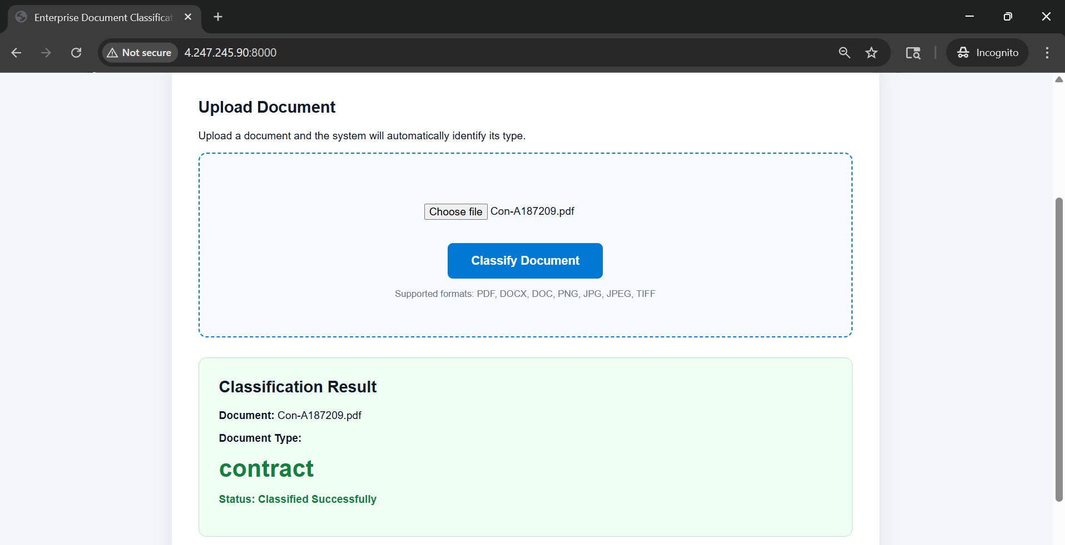

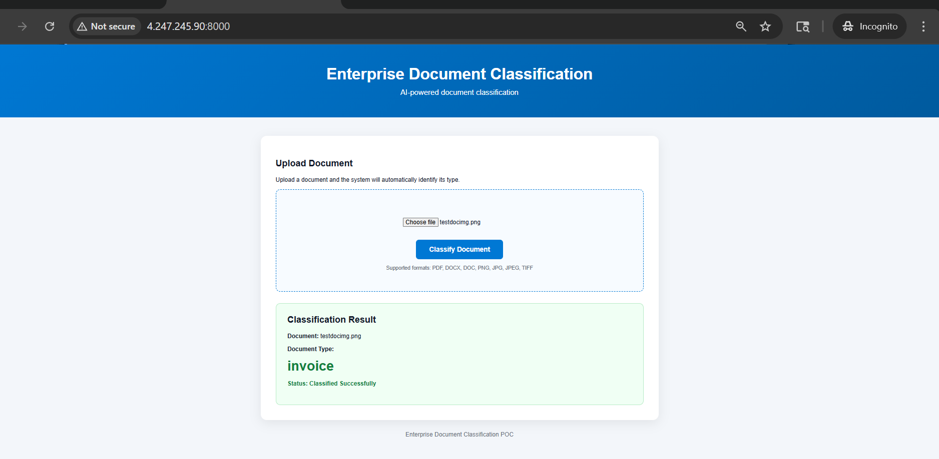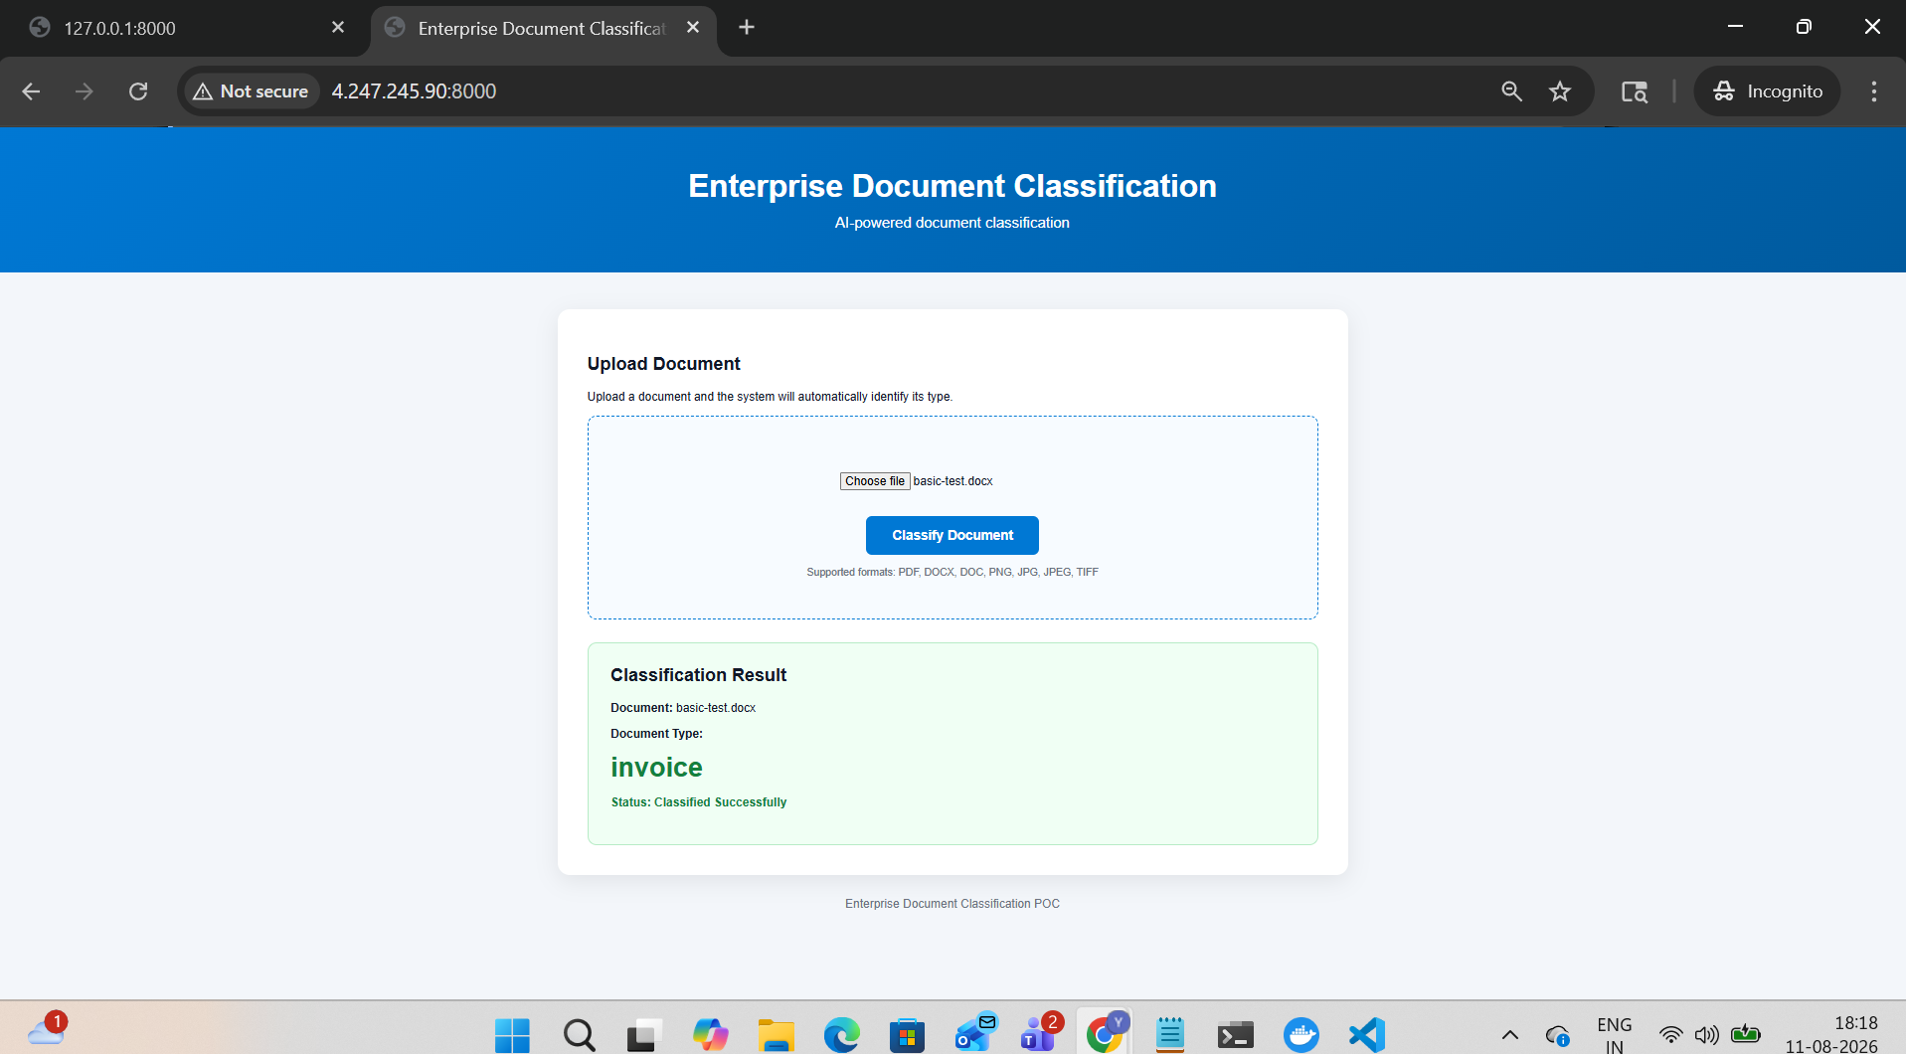

10.1 Power BI Outputs
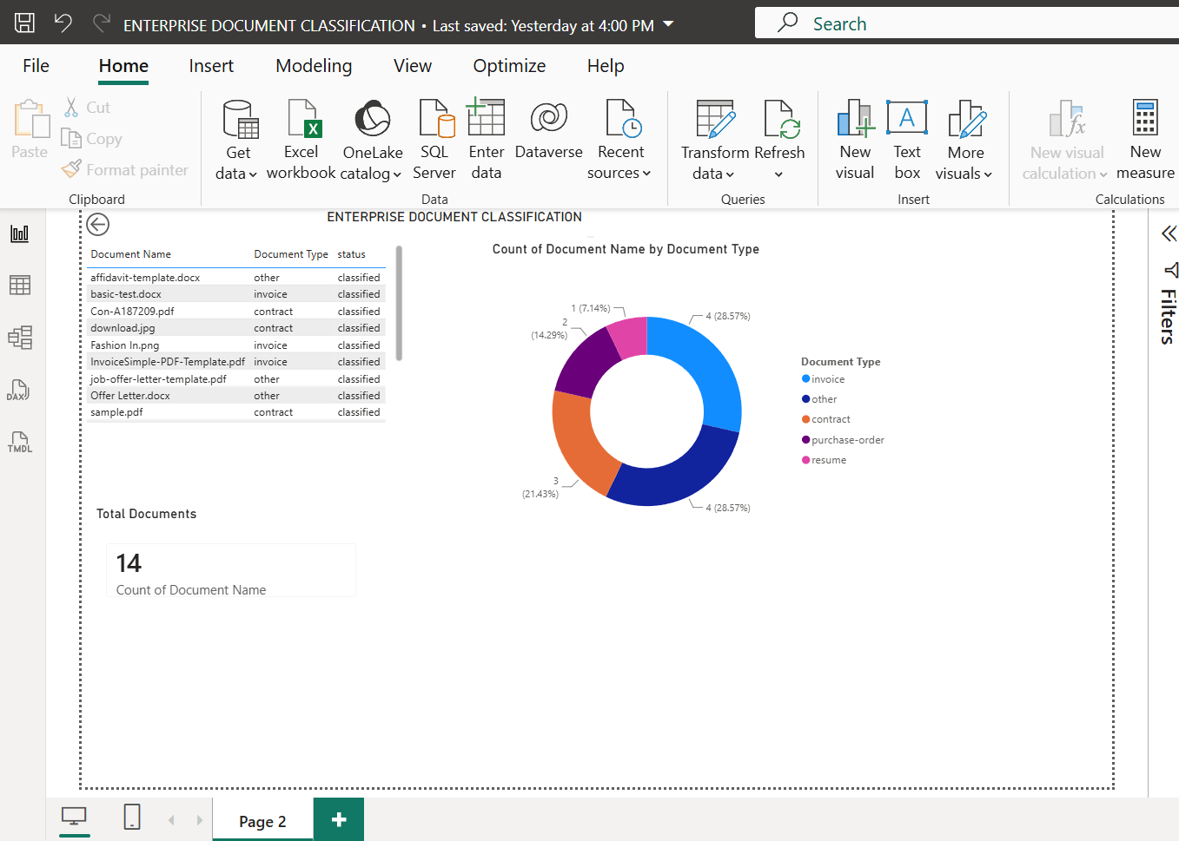

12. End-to-End Validation Checklist
Use this checklist after implementation to confirm that each major layer is functioning before customer handover.
Area | Validation | Expected Result
Repository | GitHub repository accessible | Project files and workflow are available.
Python | Virtual environment active | Required packages import successfully.
Blob Storage | Test document accessible | Application can read the raw document.
Ingestion | document_ingestion.py runs | Document metadata/input is prepared.
Document Intelligence | Custom classifier test succeeds | Configured document class is returned.
Training data | training_data.csv and validation_data.csv available | Training and validation data load correctly.
ML training | train.py completes | document_classifier.pkl is generated.
Inference | predict.py completes | Model returns a sensible prediction.
Model Registry | Model appears in Azure ML | Registered model is visible under Models.
API | FastAPI starts locally | Classification API responds.
Docker | Container starts locally | API is reachable on the mapped port.
ACR | Image is pushed | Image tag is visible in enterpisedocacr.
AKS | Pods are running | Deployment is healthy.
Service | External service is reachable | Application can be accessed through the service endpoint.
CI/CD | GitHub Actions workflow succeeds | Image build/push/deployment completes.
Power BI | Blob output is transformed | Classification results appear in the report.
Dashboard | Card + donut + table visible | Document counts and document types are displayed.

13. Implemented Project File Reference
The following files are the key implementation files referenced throughout the deployment guide. The guide intentionally documents file names and execution commands rather than embedding application source code.
Layer | File / Path | Purpose
Storage test | src/utils/blob_storage_test.py | Validates Azure Blob Storage connectivity and access.
Storage | src/storage/blob_client.py | Blob Storage client/helper layer.
Ingestion | src/ingestion/document_ingestion.py | Reads and prepares document input.
Training | src/training/train.py | Trains the TF-IDF + Logistic Regression classifier.
Inference | src/inference/predict.py | Loads the trained model and tests predictions.
Model registration | src/training/register_model.py | Registers the trained model in Azure ML.
API | src/api/app.py | FastAPI inference/API layer.
Container | Dockerfile | Build definition for the API container.
Kubernetes | k8s/deployment.yaml | AKS deployment/service definition.
CI/CD | .github/workflows/deploy.yml | GitHub Actions deployment workflow.
Model artifact | models/document_classifier.pkl | Trained classifier artifact.
Training data | data/processed/training_data.csv | Model training dataset.
Validation data | data/processed/validation_data.csv | Model validation dataset.

14. Implementation Summary
The implementation was completed as an end-to-end document classification pipeline covering storage, document analysis, machine learning, model registration, API packaging, Kubernetes deployment, CI/CD and reporting.
The final implementation sequence is:
1. Project and development environment
2. Azure Blob Storage
3. Document ingestion
4. Azure AI Document Intelligence custom classification
5. Training and validation data preparation
6. TF-IDF + Logistic Regression model training
7. Local inference validation
8. Azure ML model registration
9. FastAPI inference API
10. Docker image build
11. Azure Container Registry
12. AKS deployment
13. GitHub Actions authentication and deployment
14. Power BI data transformation
15. Power BI dashboard

